**Inferences Concerning the Regression Coefficients (Slopes)**

Before a regression equation is used for the purpose of estimation or prediction, we should first determine if a relationship appears to exist between the two variables in the population, or whether the observed relationship in the sample could have occurred by chance.

For the sake of simplicity, we will consider Simple Linear Regression only here, although everything applies to the case of Multiple Linear Regression also.

In the absence of any relationship in the population, the slope of the population regression line would, by definition, be zero: ***β1 = 0***.

Therefore the usual null and alternative hypotheses tested is

H0: ***β1 = 0***.

H1: ***β1 ≠ 0***.

Such a test is equivalent to a formal test of the linear relationship between the two variables.

If we fail to reject the null hypothesis, we must conclude that the independent variable has no bearing on the value of the dependent variable.

The null hypothesis can also be formulated as a one-tail test, in which case the alternative

hypothesis is not simply that the two variables are related, but that the relationship is of a specific type (direct or inverse).

A hypothesized value of the slope is tested by computing a t statistic and using n - 2 degrees of freedom. Two degrees of freedom are lost in the process of inference because two parameter estimates, ***b0***and ***b1***, are included in the regression equation.

The standard formula is

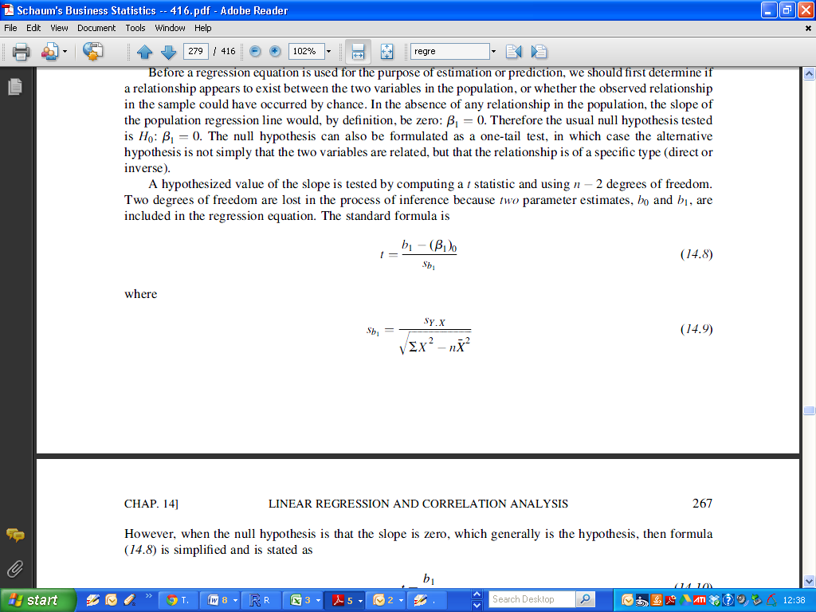

However, when the null hypothesis is that the slope is zero, which generally is the hypothesis, then the formula is simplified and is stated as:

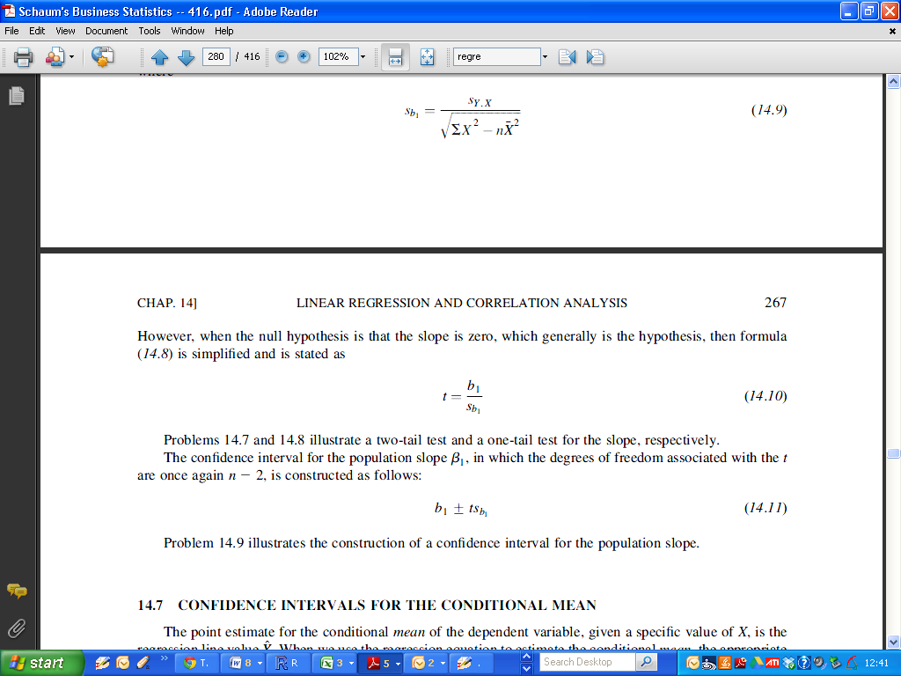

**Inferences Concerning the Intercept**

The same approach to formal testing is equally applicable to the Intercept.

Therefore the usual null and alternative hypotheses tested is

H0: ***β0= 0***.

H1: ***β0 ≠ 0***.

We will discuss the use of such a test in future classes. It is not usually given as much attention, in general. However it is quite a useful test for chemists.

**Performing Inference procedures for intercept and slope.**

Recall the example from the last class: Concentration and Fluoresence.

|  |
| --- |
| > Fit  Call:  lm(formula = Fluo ~ Conc)  Coefficients:  (Intercept) Conc  1.518 1.930 |

To compute the p-values for inferences on the intercept and slope, we use the summary command, specifying the regression model we have chosen to use.

The p-value is written as Pr(>|t|). Additionally there is a useful visual aid : the number of asterisks beside the p-value, if the p-value is sufficiently small.

A guide to reading the significance codes is provided in the output.

* Three asterisks indicate a p-value of less than 0.001
* Two asterisks indicate a p-value of less than 0.01
* One asterisk indicate a p-value of less than 0.05

(Remark: we have chosen 0.01 as a threshold for rejecting the null hypothesis. This is an arbitrary level)

|  |
| --- |
| > summary(Fit)  Call:  lm(formula = Fluo ~ Conc)  Residuals:  1 2 3 4 5 6 7  0.58214 -0.37857 -0.23929 -0.50000 0.33929 0.17857 0.01786  Coefficients:  Estimate Std. Error t value Pr(>|t|)  (Intercept) 1.5179 0.2949 5.146 0.00363 **  Conc 1.9304 0.0409 47.197 8.07e-08 ***  ---  Signif. codes: 0 ‘***’ 0.001 ‘**’ 0.01 ‘*’ 0.05 ‘.’ 0.1 ‘ ’ 1  Residual standard error: 0.4328 on 5 degrees of freedom  Multiple R-squared: 0.9978, Adjusted R-squared: 0.9973  F-statistic: 2228 on 1 and 5 DF, p-value: 8.066e-08 |

We reject the null hypotheses for both the slope and intercept.

|  |
| --- |
| > cor(Cheese)  Taste Acetic H2S Lactic  Taste 1.0000000 0.5495393 0.7557523 0.7042362  Acetic 0.5495393 1.0000000 0.6179559 0.6037826  H2S 0.7557523 0.6179559 1.0000000 0.6448123  Lactic 0.7042362 0.6037826 0.6448123 1.0000000 |

Simple Linear Regression Models

|  |
| --- |
| > FitA = lm(Taste ~ Acetic, data = Cheese)  > FitB = lm(Taste ~ H2S, data = Cheese)  > FitC = lm(Taste ~ Lactic, data = Cheese) |

|  |
| --- |
| > summary(FitA)  Call:  lm(formula = Taste ~ Acetic, data = Cheese)  Residuals:  Min 1Q Median 3Q Max  -29.642 -7.443 2.082 6.597 26.581  Coefficients:  Estimate Std. Error t value Pr(>|t|)  (Intercept) -61.499 24.846 -2.475 0.01964 *  Acetic 15.648 4.496 3.481 0.00166 **  ---  Signif. codes: 0 ‘***’ 0.001 ‘**’ 0.01 ‘*’ 0.05 ‘.’ 0.1 ‘ ’ 1  Residual standard error: 13.82 on 28 degrees of freedom  Multiple R-squared: 0.302, Adjusted R-squared: 0.2771  F-statistic: 12.11 on 1 and 28 DF, p-value: 0.001658 |

|  |
| --- |
| > summary(FitB)  Call:  lm(formula = Taste ~ H2S, data = Cheese)  Residuals:  Min 1Q Median 3Q Max  -15.426 -7.611 -3.491 6.420 25.687  Coefficients:  Estimate Std. Error t value Pr(>|t|)  (Intercept) -9.7868 5.9579 -1.643 0.112  H2S 5.7761 0.9458 6.107 1.37e-06 ***  ---  Signif. codes: 0 ‘***’ 0.001 ‘**’ 0.01 ‘*’ 0.05 ‘.’ 0.1 ‘ ’ 1  Residual standard error: 10.83 on 28 degrees of freedom  Multiple R-squared: 0.5712, Adjusted R-squared: 0.5558  F-statistic: 37.29 on 1 and 28 DF, p-value: 1.374e-06 |

|  |
| --- |
| > summary(FitC)  Call:  lm(formula = Taste ~ Lactic, data = Cheese)  Residuals:  Min 1Q Median 3Q Max  -19.9439 -8.6839 -0.1095 8.9998 27.4245  Coefficients:  Estimate Std. Error t value Pr(>|t|)  (Intercept) -29.859 10.582 -2.822 0.00869 **  Lactic 37.720 7.186 5.249 1.41e-05 ***  ---  Signif. codes: 0 ‘***’ 0.001 ‘**’ 0.01 ‘*’ 0.05 ‘.’ 0.1 ‘ ’ 1  Residual standard error: 11.75 on 28 degrees of freedom  Multiple R-squared: 0.4959, Adjusted R-squared: 0.4779  F-statistic: 27.55 on 1 and 28 DF, p-value: 1.405e-05 |

Regression Models using two or more independent variables.

|  |
| --- |
| > Fit1 = lm(Taste ~ Acetic + H2S, data = Cheese)  > Fit2 = lm(Taste ~ Acetic + Lactic, data = Cheese)  > Fit3 = lm(Taste ~ H2S + Lactic, data = Cheese)  > Fit4 = lm(Taste ~ Acetic + H2S + Lactic, data = Cheese) |

Akaike Information Criterion

|  |
| --- |
| > AIC(FitA)  [1] 246.6389  > AIC(FitB)  [1] 232.0245  > AIC(FitC)  [1] 236.8724 |

For the multiple linear regression models.

|  |
| --- |
| > AIC(Fit1)  [1] 233.2438  > AIC(Fit2)  [1] 237.3884  > AIC(Fit3)  [1] 227.7838  > AIC(Fit4)  [1] 229.7775 |

Summary of model selection metrics.

|  |  |  |  |  |
| --- | --- | --- | --- | --- |
| Model | Ind. Variables | Multiple R2 | Adjusted R2 | AIC |
|  |  | (highest *) | (highest *) | (lowest *) |
| FitA | Acetic | 0.3020 | 0.2771 | 246.6389 |
| FitB | H2S | 0.5712 | 0.5558 | 232.0245 |
| FitC | Lactic | 0.4959 | 0.4779 | 236.8724 |
| Fit1 | Acetic, H2S | 0.5822 | 0.5512 | 233.2438 |
| Fit2 | Acetic, Lactic | 0.5203 | 0.4847 | 237.3884 |
| Fit3 | H2S, Lactic | 0.6517 | 0.6259 * | 227.7838 * |
| Fit4 | All Three | 0.6518 * | 0.6116 | 229.7775 |